Searching & Sorting

First and last occurrences of X
Find first and last positions of an element in a sorted array

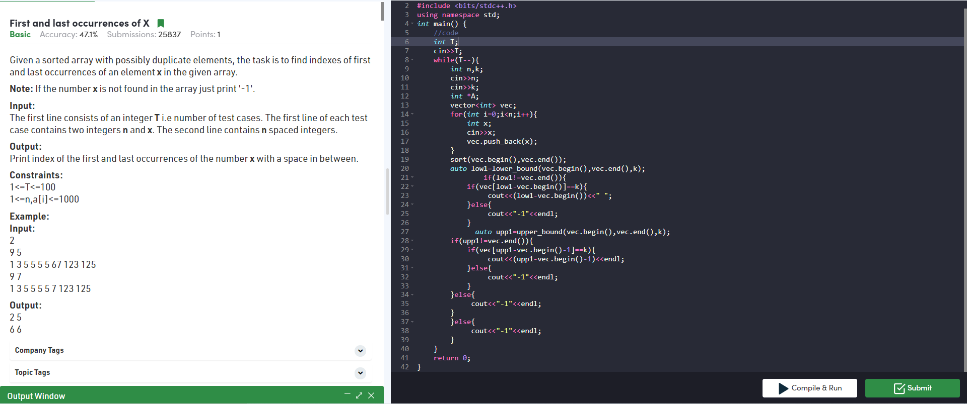
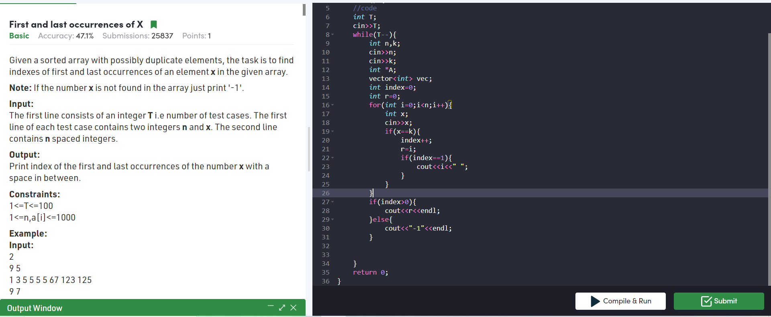
Value equal to index value
Find a Fixed Point (Value equal to index) in a given array

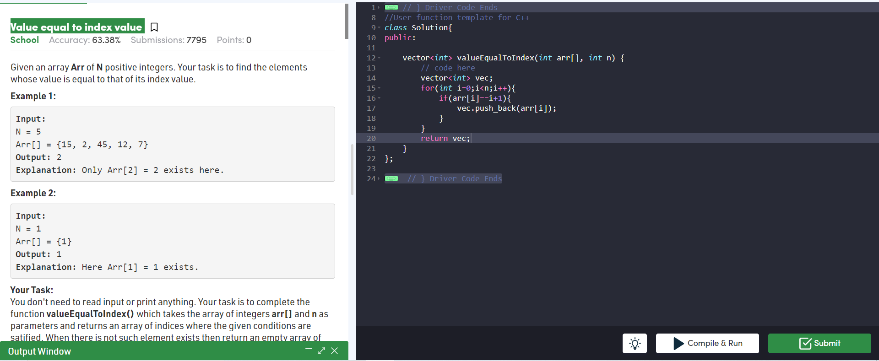
33. Search in Rotated Sorted Array
Search in a rotated sorted array

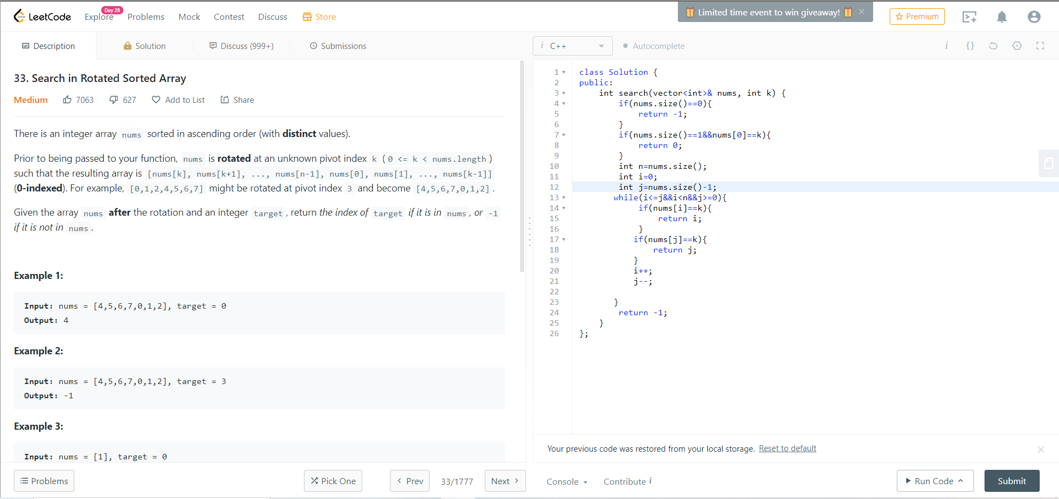
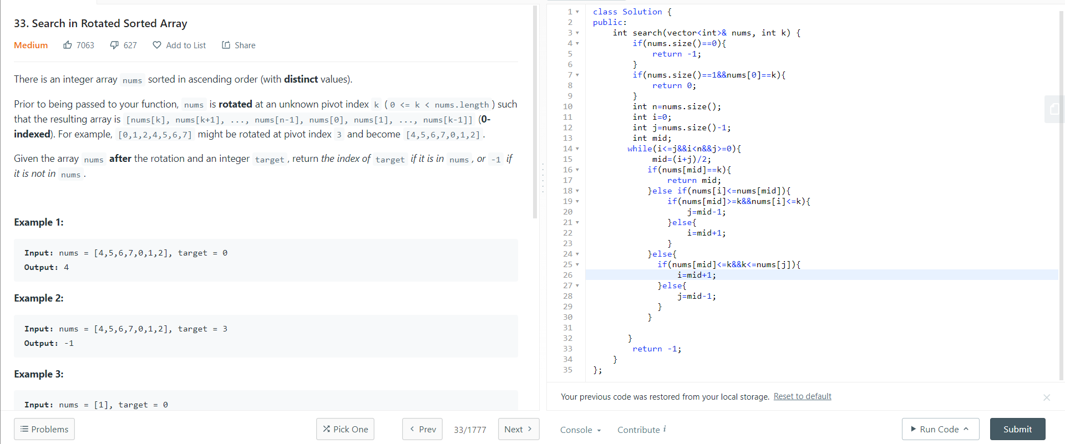

Count Squares
square root of an integer

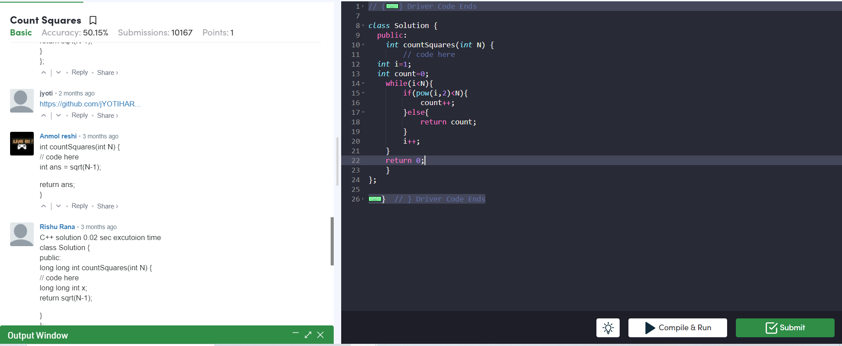
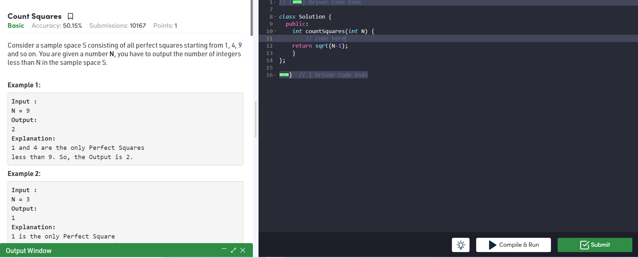

Middle of Three
Maximum and minimum of an array using minimum number of comparisons

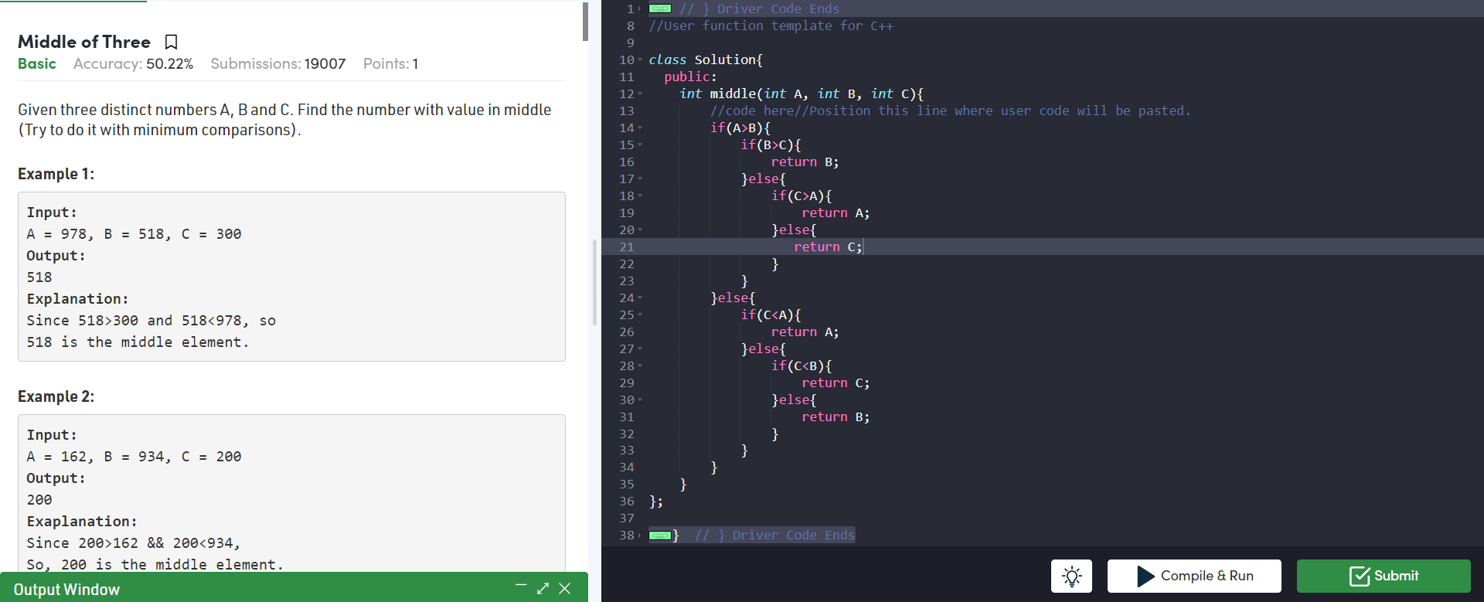
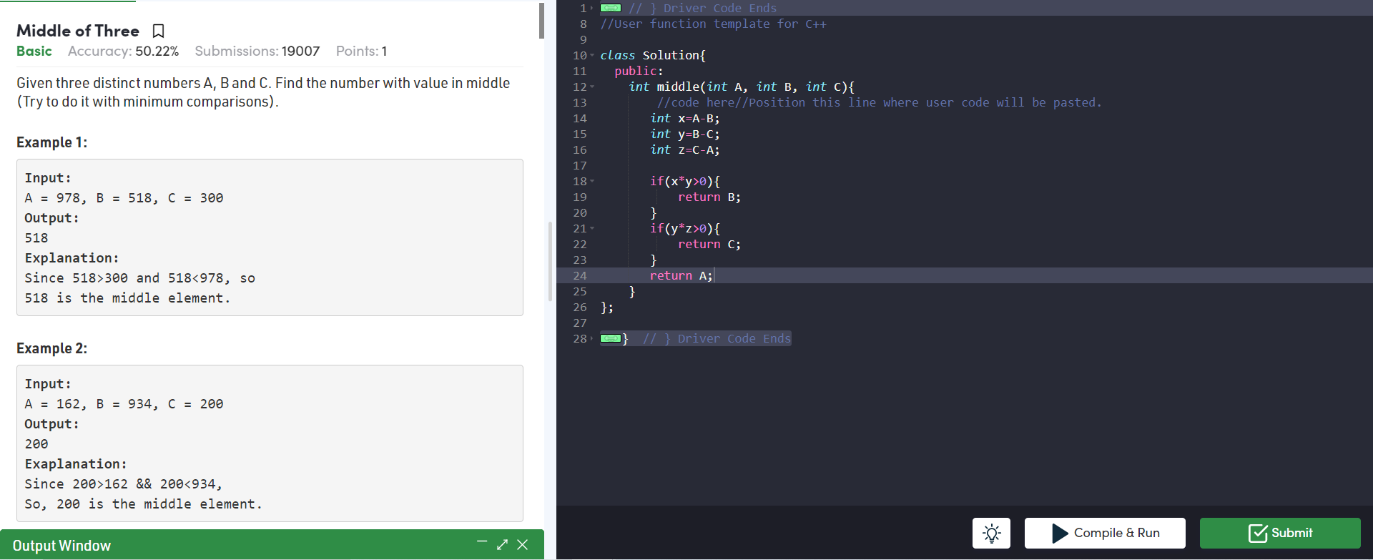

Find Missing And Repeating
Find the repeating and the missing

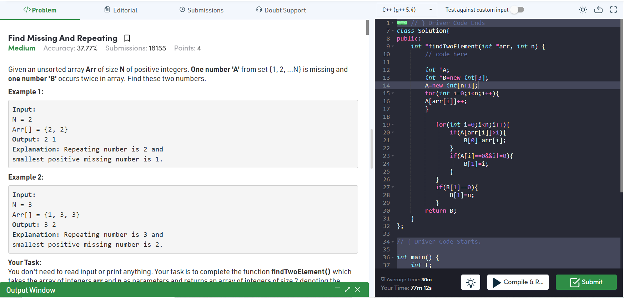

Majority Element
Find the repeating and the missing

OR
BitMasking_method
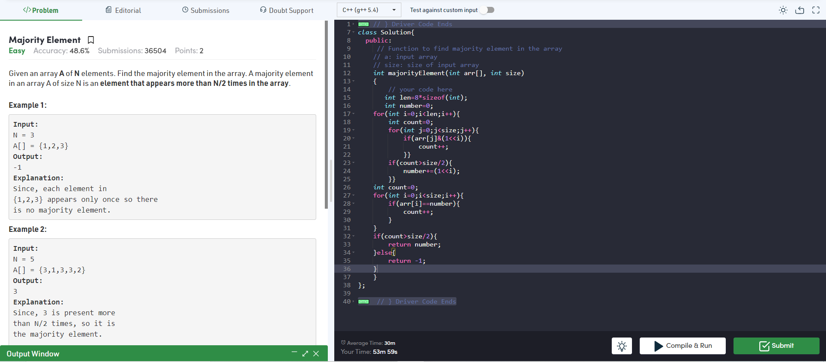

int len=8*sizeof(int);
int number=0;
for(int i=0;i<len;i++){
int count=0;
for(int j=0;j<size;j++){
if(arr[j]&(1<<i)){
count++;
}}
if(count>size/2){
number+=(1<<i);
}}
int count=0;
for(int i=0;i<size;i++){
if(arr[i]==number){
count++;
}
}
if(count>size/2){
return number;
}else{
return -1;
}

Find Missing And Repeating
